**AMERICAN INTERNATIONAL UNIVERSITY–BANGLADESH (AIUB)**

**FACULTY OF SCIENCE & TECHNOLOGY**

**DEPARTMENT OF COMPUTER SCIENCE & ENGINEERING**

**INTRODUCTION TO DATABASE**

**Spring 2022-2023**

**Section: M, Group: 01**

**PROJECT ON**

***Air Ticket Booking & Boarding Management System***

**Supervised By**

**KAWSER IROM RUSHEE**

**Submitted By**

|  |  |  |
| --- | --- | --- |
| **Name** | **ID** | **Contribution** |
| **1. NILOY, NAFIUR RAHMAN** | **22-46459-1** |  |
| **2. RAHMAN, AZMINUR** | **22-46588-1** |  |
| **3. KUNDU, SAIKOT** | **22-46615-1** |  |
| **4. SARWAR, MD. SAKIB** | **22-46625-1** |  |

Date of Submission: **May 17, 2023**

**TABLE OF CONTENTS**

|  |  |  |
| --- | --- | --- |
| **SL No** | **Topic Name** | **Page No** |
| 01. | Cover Page | 01 |
| 02. | Table of Contents | 02 |
| 03. | Introduction | 03 |
| 04. | Scenario | 03 |
| 05. | ER-DIAGRAM (Screenshot) | 04 |
| 06. | ER-DIAGRAM (Final) | 05 |
| 07. | Normalization | 06-10 |
| 08. | Final Tables | 10 |
| 09. | Table Creation | 10-12 |
| 10. | Table Creation (Screenshot) | 12-16 |
| 11. | Data Insertion | 17-19 |
| 12. | Joining | 20-21 |
| 13. | Subquery | 22-23 |
| 14. | View | 24 |
| 15. | Add Constraint | 25 |



**Introduction:**

‘Uran’ is a company that operates an air ticket booking and boarding management system. The system is managed by managers who oversee ticket agents. Ticket agents sell tickets to customers. Customers can buy tickets for themselves or for other passengers. Passenger must need ticket for boarding in planes. The company also store the route of planes.

**Scenario:**

The owners of an air ticket booking and boarding management system ‘Uran’ wants to create a database management system for their company. In this company A manager can **manage** many ticket agent. Managers can be identified using their unique manager ID. Each manager's name, phone number, and salary are stored in the database. One or more ticket agent may work under a manager. A ticket agent can **sell** many ticket. Every agent’s name, phone, salary, as well as a unique agent ID is recorded. Tickets have their fare, amount, departure, destination, departure date, purchase date and baggage stored as records along with a unique ticket ID for ticket. A customer must **purchase** ticket for traveling. During purchasing ticket payment id and total fare are also stored in the database. Customers are identified by their unique Customer ID. Aside from that, a customer's name, address with city & country, phone number, age, gender, and payment history (if available) are also recorded in the database. A customer may be a passenger themselves or **buy as/for** tickets for another passenger. Passengers can be distinctly identified with the help of their Passenger ID. Additionally, a passenger's name, address with city & country, age, phone number, and gender are also stored within the database. Passengers need tickets for traveling. Passengers will use their tickets for **boarding** to plane. Each plane has a distinct plane ID alongside its terminal number, take-off airport, take-off time, destination and capacity. Every passenger **sits on** a seat. Every seat identified by unique seat id alongside seat type. A plane has many seats. A plane **travel in** one route towards their destination. These routes are distinctly marked using a route ID and it’s had distance.

**ER-DIAGRAM (Screenshot):**

At the beginning

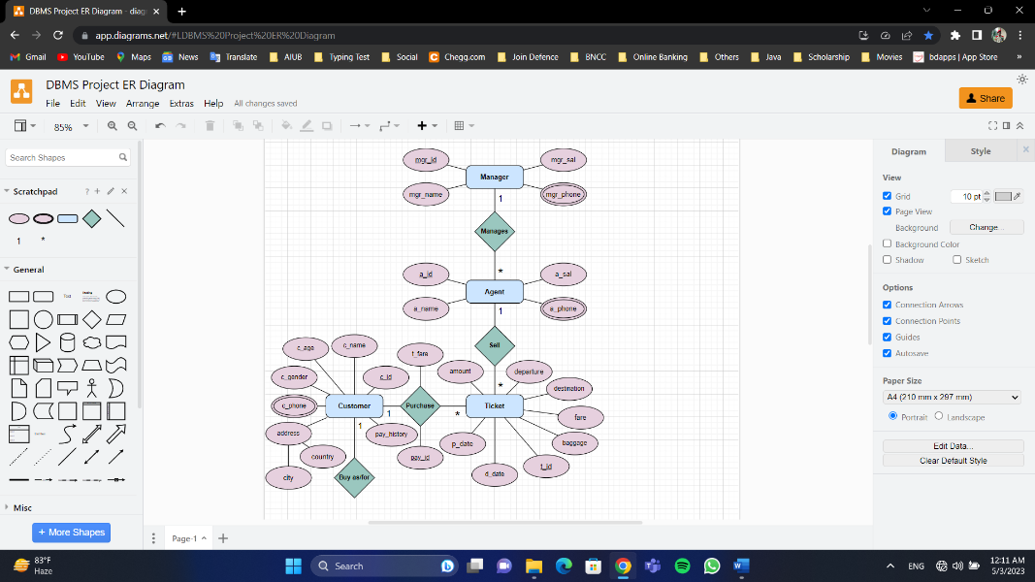

At the Middle

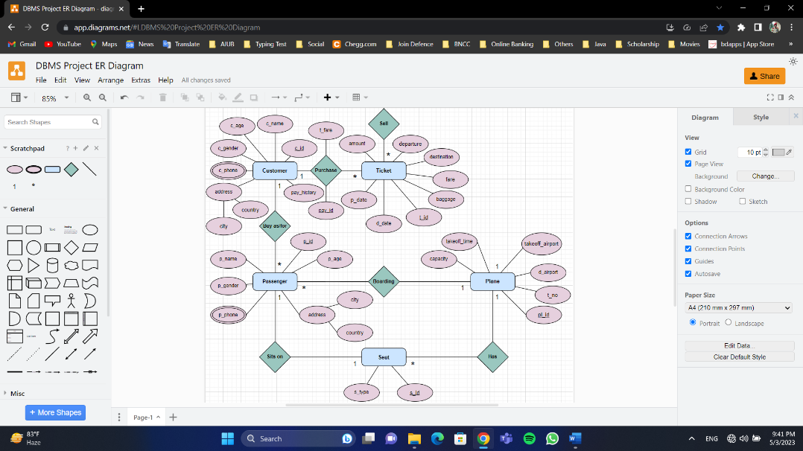

At nearly end

**ER-DIAGRAM (Final):**

ER-DIAGRAM

**Normalization:**

* **Manages**

**UNF:** mgr_id, mgr_name, mgr_sal, mgr_phone, a_id, a_name, a_sal, a_phone

**1NF:** (**mgr_phone** and **a_phone** is multivalued attribute)

mgr_id, mgr_name, mgr_sal, mgr_phone, a_id, a_name, a_sal, a_phone

**2NF:**

1. mgr_id, mgr_name, mgr_sal
2. mgr_phone*,* mgr_id (fk)
3. a_id, a_name, a_sal, mgr_id (fk)
4. a_phone*,* a_id (fk)

**3NF:** (No Transitive Dependency)

1. mgr_id, mgr_name, mgr_sal
2. mgr_phone*,* mgr_id (fk)
3. a_id, a_name, a_sal, mgr_id (fk)
4. a_phone*,* a_id (fk)

**Tables:**

1. mgr_id, mgr_name, mgr_sal
2. mgr_phone*,* mgr_id (fk)
3. a_id, a_name, a_sal, mgr_id (fk)
4. a_phone*,* a_id (fk)

* **Sell**

**UNF:** a_id, a_name, a_sal, a_phone, t_id, amount, fare, departure, destination, p_date, d_date, baggage

**1NF:** (**a_phone**is a multivalued attribute)

a_id, a_name, a_sal, a_phone, t_id, amount, fare, departure, destination, p_date, d_date, baggage

**2NF:**

1. a_id, a_name, a_sal
2. a_phone, a_id (fk)
3. t_id, amount, fare, departure, destination, p_date, d_date, baggage, a_id (fk)

**3NF:** (No Transitive Dependency)

1. a_id, a_name, a_sal
2. a_phone, a_id (fk)
3. t_id, amount, fare, departure, destination, p_date, d_date, baggage, a_id (fk)

**Tables:**

1. a_id, a_name, a_sal
2. a_phone, a_id (fk)
3. t_id, amount, fare, departure, destination, p_date, d_date, baggage, a_id (fk)

* **Purchase**

**UNF:** t_id, amount, fare, departure, destination, p_date, d_date, baggage, c_id, c_name, c_age, c_gender, city, country, c_phone, pay_history, pay_id, t_fare

**1NF:** (**c_phone** is a multivalued attribute)

t_id, amount, fare, departure, destination, p_date, d_date, baggage, c_id, c_name, c_age, c_gender, city, country, c_phone, pay_history, pay_id, t_fare

**2NF:**

1. t_id, amount, fare, departure, destination, p_date, d_date, baggage, c_id (fk)
2. c_id, c_name, c_age, c_gender, city, country, pay_history
3. c_phone, c_id (fk)
4. pay_id, t_fare, c_id (fk), t_id (fk)

**3NF:** (Transitive Dependency)

1. t_id, amount, fare, departure, destination, p_date, d_date, baggage, c_id (fk)
2. c_id, c_name, c_age, c_gender, pay_history
3. city, country, c_id (fk)
4. c_phone, c_id (fk)
5. pay_id, t_fare, c_id (fk), t_id (fk)

**Tables:**

1. t_id, amount, fare, departure, destination, p_date, d_date, baggage, c_id (fk)
2. c_id, c_name, c_age, c_gender, pay_history
3. city, country, c_id (fk)
4. c_phone, c_id (fk)
5. pay_id, t_fare, c_id (fk), t_id (fk)

* **Buy As/For**

**UNF:** c_id, c_name, c_age, c_gender, city, country, c_phone, pay_history, p_id, p_name, p_gender, p_age, city, country, p_phone

**1NF:** (**c_phone**, **p_phone** is a multivalued attribute)

c_id, c_name, c_age, c_gender, city, country, c_phone, pay_history, p_id, p_name, p_gender, p_age, city, country, p_phone

**2NF:**

1. c_id, c_name, c_age, c_gender, city, country, pay_history
2. c_phone, c_id (fk)
3. p_id, p_name, p_gender, p_age, city, country, c_id (fk)
4. p_phone, p_id (fk)

**3NF:** (Transitive Dependency)

1. c_id, c_name, c_age, c_gender, pay_history
2. city, country, c_id (fk)
3. c_phone, c_id (fk)
4. p_id, p_name, p_gender, p_age, c_id (fk)
5. city, country, p_id (fk)
6. p_phone, p_id (fk)

**Table:**

1. c_id, c_name, c_age, c_gender, pay_history
2. city, country, c_id (fk)
3. c_phone, c_id (fk)
4. p_id, p_name, p_gender, p_age, c_id (fk)
5. city, country, p_id (fk)
6. p_phone, p_id (fk)

* **Boarding**

**UNF:** p_id, p_name, p_gender, p_age, city, country, p_phone, pl_id, t_no, takeoff_airport, takeoff_time, d_airport, capacity

**1NF:** (**p_phone** is a multivalued attribute)

p_id, p_name, p_gender, p_age, city, country, p_phone**,** pl_id, t_no, takeoff_airport, takeoff_time, d_airport, capacity

**2NF:**

1. p_id, p_name, p_gender, p_age, city, country, pl_id (fk)
2. p_phone, p_id (fk)
3. pl_id, t_no, takeoff_airport, takeoff_time, d_airport, capacity

**3NF:** (Transitive Dependency)

1. p_id, p_name, p_gender, p_age, pl_id (fk)
2. city, country, p_id (fk)
3. p_phone, p_id (fk)
4. pl_id, t_no, takeoff_airport, takeoff_time, d_airport, capacity

**Table:**

1. p_id, p_name, p_gender, p_age, pl_id (fk)
2. city, country, p_id (fk)
3. p_phone, p_id (fk)
4. pl_id, t_no, takeoff_airport, takeoff_time, d_airport, capacity

* **Sits On**

**UNF:** p_id, p_name, p_gender, p_age, city, country, p_phone, s_id, s_type

**1NF:** (**p_phone** is a multivalued attribute)

p_id, p_name, p_gender, p_age, city, country, p_phone**,** s_id, s_type

**2NF:**

1. p_id, p_name, p_gender, p_age, city, country
2. p_phone, p_id (fk)
3. s_id, s_type, p_id (fk)

**3NF:** (Transitive Dependency)

1. p_id, p_name, p_gender, p_age
2. city, country, p_id (fk)
3. p_phone, p_id (fk)
4. s_id, s_type, p_id (fk)

**Table:**

1. p_id, p_name, p_gender, p_age
2. city, country, p_id (fk)
3. p_phone, p_id (fk)
4. s_id, s_type, p_id (fk)

* **Has**

**UNF:** s_id, s_type, pl_id, t_no, takeoff_airport, takeoff_time, d_airport, capacity

**1NF:** (No multivalued attribute)

s_id, s_type, pl_id, t_no, takeoff_airport, takeoff_time, d_airport, capacity

**2NF:**

1. s_id, s_type, pl_id (fk)
2. pl_id, t_no, takeoff_airport, takeoff_time, d_airport, capacity

**3NF:** (No Transitive Dependency)

1. s_id, s_type, pl_id (fk)
2. pl_id, t_no, takeoff_airport, takeoff_time, d_airport, capacity

**Table:**

1. s_id, s_type, pl_id (fk)
2. pl_id, t_no, takeoff_airport, takeoff_time, d_airport, capacity

* **Travels In**

**UNF:** pl_id, t_no, takeoff_airport, takeoff_time, d_airport, capacity, r_id, distance

**1NF:** (No multivalued attribute)

pl_id, t_no, takeoff_airport, takeoff_time, d_airport, capacity, r_id, distance

**2NF:**

1. pl_id, t_no, takeoff_airport, takeoff_time, d_airport, capacity
2. r_id, distance, pl_id (fk)

**3NF:** (No Transitive Dependency)

1. pl_id, t_no, takeoff_airport, takeoff_time, d_airport, capacity
2. r_id, distance, pl_id (fk)

**Table:**

1. pl_id, t_no, takeoff_airport, takeoff_time, d_airport, capacity
2. r_id, distance, pl_id (fk)

* **Tables**

1. mgr_id, mgr_name, mgr_sal
2. mgr_phone*,* mgr_id (fk)
3. a_id, a_name, a_sal, mgr_id (fk)
4. a_phone*,* a_id (fk)
5. a_id, a_name, a_sal
6. a_phone, a_id (fk)
7. t_id, amount, fare, departure, destination, p_date, d_date, baggage, a_id (fk)
8. t_id, amount, fare, departure, destination, p_date, d_date, baggage, c_id (fk)
9. c_id, c_name, c_age, c_gender, pay_history
10. city, country, c_id (fk)
11. c_phone, c_id (fk)
12. pay_id, t_fare, c_id (fk), t_id (fk)
13. c_id, c_name, c_age, c_gender, pay_history
14. city, country, c_id (fk)
15. c_phone, c_id (fk)
16. p_id, p_name, p_gender, p_age, c_id (fk)
17. city, country, p_id (fk)
18. p_phone, p_id (fk)
19. p_id, p_name, p_gender, p_age, pl_id (fk)
20. city, country, p_id (fk)
21. p_phone, p_id (fk)
22. pl_id, t_no, takeoff_airport, takeoff_time, d_airport, capacity
23. p_id, p_name, p_gender, p_age
24. city, country, p_id (fk)
25. p_phone, p_id (fk)
26. s_id, s_type, p_id (fk)
27. s_id, s_type, pl_id (fk)
28. pl_id, t_no, takeoff_airport, takeoff_time, d_airport, capacity
29. pl_id, t_no, takeoff_airport, takeoff_time, d_airport, capacity
30. r_id, distance, pl_id (fk)

**Final Tables**

1. mgr_id, mgr_name, mgr_sal
2. mgr_phone*,* mgr_id (fk)
3. a_id, a_name, a_sal, mgr_id (fk)
4. a_phone*,* a_id (fk)
5. cc_id, city, country
6. c_id, c_name, c_age, c_gender, pay_history, cc_id (fk)
7. c_phone, c_id (fk)
8. t_id, amount, fare, departure, destination, p_date, d_date, baggage, a_id (fk), c_id (fk)
9. pay_id, t_fare, c_id (fk), t_id (fk)
10. pl_id, t_no, takeoff_airport, takeoff_time, d_airport, capacity
11. p_id, p_name, p_gender, p_age, c_id (fk), pl_id (fk), cc_id (fk)
12. p_phone, p_id (fk)
13. s_id, s_type, p_id (fk), pl_id (fk)
14. r_id, distance, pl_id (fk)

**Table Creation**

1. CREATE TABLE manager (mgr_id NUMBER(3) CONSTRAINT pk_manager PRIMARY KEY,mgr_name VARCHAR2(30) NOT NULL,mgr_sal FLOAT NOT NULL CONSTRAINT manager_sal check(mgr_sal between 50000 AND 100000));
2. CREATE TABLE manager_contact(mgr_phone NUMBER(11) CONSTRAINT pk_mgr_contact PRIMARY KEY, mgr_id NUMBER(3) NOT NULL, CONSTRAINT fk_mgr_contact FOREIGN KEY(mgr_id) REFERENCES manager(mgr_id));
3. CREATE TABLE agent(a_id NUMBER(3) CONSTRAINT pk_agent PRIMARY KEY, a_name VARCHAR2(30) NOT NULL, a_sal FLOAT NOT NULL CONSTRAINT agent_sal check(a_sal BETWEEN 20000 AND 50000), mgr_id NUMBER(3) NOT NULL, CONSTRAINT fk_agent FOREIGN KEY(mgr_id) REFERENCES manager(mgr_id));
4. CREATE TABLE agent_contact(a_phone NUMBER(11) CONSTRAINT pk_agent_contact PRIMARY KEY, a_id NUMBER(3) NOT NULL, CONSTRAINT fk_agent_contact FOREIGN KEY(a_id) REFERENCES agent(a_id));
5. CREATE TABLE address(cc_id NUMBER(3) CONSTRAINT pk_address PRIMARY KEY, city VARCHAR2(30) NOT NULL, country VARCHAR2(30) NOT NULL);
6. CREATE TABLE customer(c_id NUMBER(10) CONSTRAINT pk_customer PRIMARY KEY, c_name VARCHAR2(30) NOT NULL, c_age NUMBER(3) NOT NULL CONSTRAINT c_age CHECK(c_age>0), c_gender VARCHAR2(6) NOT NULL CONSTRAINT c_gender CHECK (c_gender IN ('MALE', 'FEMALE', 'OTHERS')), pay_history NUMBER(10), cc_id NUMBER(3) NOT NULL, CONSTRAINT fk_address_customer FOREIGN KEY (cc_id) REFERENCES address(cc_id));
7. CREATE TABLE customer_contact(c_phone NUMBER(11) CONSTRAINT pk_c_contact PRIMARY KEY, c_id NUMBER(10) NOT NULL, CONSTRAINT fk_c_contact FOREIGN KEY(c_id) REFERENCES customer(c_id));
8. CREATE TABLE ticket(t_id NUMBER(10) CONSTRAINT pk_ticket PRIMARY KEY, amount NUMBER(2) NOT NULL, fare FLOAT NOT NULL, departure VARCHAR2(100) NOT NULL, destination VARCHAR2(100) NOT NULL, p_date DATE NOT NULL, d_date DATE NOT NULL, baggage NUMBER(2) NOT NULL, a_id NUMBER(3) NOT NULL, c_id NUMBER(10) NOT NULL, CONSTRAINT fk_agent_ticket FOREIGN KEY (a_id) REFERENCES agent (a_id),CONSTRAINT fk_customer_ticket FOREIGN KEY (c_id) REFERENCES customer (c_id));
9. CREATE TABLE payment(pay_id NUMBER(10) CONSTRAINT pk_payment PRIMARY KEY, t_fare FLOAT NOT NULL, c_id NUMBER(10) NOT NULL, t_id NUMBER(10) NOT NULL, CONSTRAINT fk_customer_payment FOREIGN KEY (c_id) REFERENCES customer (c_id), CONSTRAINT fk_ticket_payment FOREIGN KEY (t_id) REFERENCES ticket(t_id));
10. CREATE TABLE plane(pl_id NUMBER(3) CONSTRAINT pk_plane PRIMARY KEY, t_no NUMBER(3) NOT NULL, takeoff_airport VARCHAR2(100) NOT NULL, takeoff_time DATE NOT NULL, d_airport VARCHAR2(100) NOT NULL, capacity NUMBER(3) NOT NULL);
11. CREATE TABLE passenger(p_id NUMBER(10) CONSTRAINT pk_passenger PRIMARY KEY, p_name VARCHAR2(30) NOT NULL, p_gender VARCHAR2(6) NOT NULL CONSTRAINT p_gender CHECK (p_gender IN ('MALE', 'FEMALE', 'OTHERS')), p_age NUMBER(3) NOT NULL CONSTRAINT p_age CHECK(p_age>0), c_id NUMBER(10) NOT NULL, pl_id NUMBER(3) NOT NULL, cc_id NUMBER(3) NOT NULL, CONSTRAINT fk_customer_passenger FOREIGN KEY (c_id) REFERENCES customer(c_id), CONSTRAINT fk_plane_passenger FOREIGN KEY (pl_id) REFERENCES plane (pl_id), CONSTRAINT fk_address_passenger FOREIGN KEY (cc_id) REFERENCES address(cc_id));
12. CREATE TABLE passenger_contact(p_phone NUMBER(11) CONSTRAINT pk_p_contact PRIMARY KEY, p_id NUMBER(10) NOT NULL, CONSTRAINT fk_p_contact FOREIGN KEY(p_id) REFERENCES passenger(p_id));
13. CREATE TABLE seat(s_id NUMBER(3) CONSTRAINT pk_seat PRIMARY KEY, s_type VARCHAR2(20) NOT NULL, p_id NUMBER(10) NOT NULL, pl_id NUMBER(3) NOT NULL, CONSTRAINT fk_passenger_seat FOREIGN KEY (p_id) REFERENCES passenger(p_id), CONSTRAINT fk_plane_seat FOREIGN KEY (pl_id) REFERENCES plane (pl_id));
14. CREATE TABLE route(r_id NUMBER(3) CONSTRAINT pk_route PRIMARY KEY, distance VARCHAR2(10) NOT NULL, pl_id NUMBER(3) NOT NULL, CONSTRAINT fk_plane_route FOREIGN KEY (pl_id) REFERENCES plane (pl_id));

**Table Creation (Screenshot)**

1. **Manager**

1. **Manager Contact**

1. **Agent**

1. **Agent Contact**

1. **Address**

1. **Customer**

1. **Customer Contact**

1. **Ticket**

1. **Payment**

1. **Plane**

1. **Passenger**

1. **Passenger Contact**

1. **Seat**

1. **Route**

**Data Insertion**:

1. **Manager**
2. INSERT INTO manager(mgr_id, mgr_name, mgr_sal) VALUES(100, 'Kawser', 99999);
3. INSERT INTO manager(mgr_id, mgr_name, mgr_sal) VALUES(200, 'Irom', 89999);
4. INSERT INTO manager(mgr_id, mgr_name, mgr_sal) VALUES(300, 'Rushee', 60000);
5. **Manager Contact**
6. INSERT INTO manager_contact(mgr_phone, mgr_id) VALUES(01765238741, 100);
7. INSERT INTO manager_contact(mgr_phone, mgr_id) VALUES(01768738741, 200);
8. INSERT INTO manager_contact(mgr_phone, mgr_id) VALUES(01763438741, 300);
9. **Agent**
   1. INSERT INTO agent(a_id, a_name, a_sal, mgr_id) VALUES(459, 'Niloy', 30000, 100);
   2. INSERT INTO agent(a_id, a_name, a_sal, mgr_id) VALUES(588, 'Azminur', 45000, 300);
   3. INSERT INTO agent(a_id, a_name, a_sal, mgr_id) VALUES(625, 'Sakib', 40000, 200);
   4. INSERT INTO agent(a_id, a_name, a_sal, mgr_id) VALUES(615, 'Saikot', 35000, 200);
10. **Agent Contact**
11. INSERT INTO agent_contact(a_phone, a_id) VALUES(01763438778, 459);
12. INSERT INTO agent_contact(a_phone, a_id) VALUES(01763438711, 588);
13. INSERT INTO agent_contact(a_phone, a_id) VALUES(01763438767, 625);
14. INSERT INTO agent_contact(a_phone, a_id) VALUES(01763438744, 615);
15. **Address**
16. INSERT INTO address(cc_id, city, country) VALUES(10, 'Dhaka', 'Bangladesh');
17. INSERT INTO address(cc_id, city, country) VALUES(20, 'Chittagong', 'Bangladesh');
18. INSERT INTO address(cc_id, city, country) VALUES(30, 'Rajshahi', 'Bangladesh');
19. INSERT INTO address(cc_id, city, country) VALUES(40, 'Khulna', 'Bangladesh');
20. INSERT INTO address(cc_id, city, country) VALUES(50, 'Barishal', 'Bangladesh');
21. INSERT INTO address(cc_id, city, country) VALUES(60, 'Sylhet', 'Bangladesh');
22. INSERT INTO address(cc_id, city, country) VALUES(70, 'Rangpur', 'Bangladesh');
23. INSERT INTO address(cc_id, city, country) VALUES(80, 'Mymensingh', 'Bangladesh');
24. **Customer**
    * 1. INSERT INTO customer(c_id, c_name, c_age, c_gender, pay_history, cc_id) VALUES(22466251, 'Shaon', 22, 'MALE', 9817, 30);
      2. INSERT INTO customer(c_id, c_name, c_age, c_gender, pay_history, cc_id) VALUES(22465881, 'Rahman', 22, 'MALE', 6591, 40);
      3. INSERT INTO customer(c_id, c_name, c_age, c_gender, pay_history, cc_id) VALUES(22464591, 'Nafiur', 69, 'MALE', 23221, 80);
      4. INSERT INTO customer(c_id, c_name, c_age, c_gender, pay_history, cc_id) VALUES(22464592, 'Kundu', 15, 'MALE', 21231, 30);
25. **Customer Contact**
26. INSERT INTO customer_contact(c_phone, c_id) VALUES(01954879621, 22465881);
27. INSERT INTO customer_contact(c_phone, c_id) VALUES(01935489647, 22466251);
28. INSERT INTO customer_contact(c_phone, c_id) VALUES(01821365482, 22464591);
29. INSERT INTO customer_contact(c_phone, c_id) VALUES(01132654791, 22464592);
30. **Ticket**
31. INSERT INTO ticket(t_id, amount, fare, departure, destination, p_date, d_date, baggage, a_id, c_id) VALUES(45698745, 1, 4699, 'DHK', 'JES', TO_DATE('08-05-2023', 'DD-MM-YYYY'), TO_DATE('15-05-2023', 'DD-MM-YYYY'), 20, 459, 22466251);
32. INSERT INTO ticket(t_id, amount, fare, departure, destination, p_date, d_date, baggage, a_id, c_id) VALUES(45698565, 2, 9398, 'DHK', 'JES', TO_DATE('09-05-2023', 'DD-MM-YYYY'), TO_DATE('15-05-2023', 'DD-MM-YYYY'), 30, 588, 22465881);
33. INSERT INTO ticket(t_id, amount, fare, departure, destination, p_date, d_date, baggage, a_id, c_id) VALUES(45698234, 2, 9398, 'DHK', 'JES', TO_DATE('11-05-2023', 'DD-MM-YYYY'), TO_DATE('15-05-2023', 'DD-MM-YYYY'), 50, 615, 22464591);
34. **Payment**
35. INSERT INTO payment(pay_id, t_fare, c_id, t_id) VALUES(1578811645, 4699, 22466251, 45698745);
36. INSERT INTO payment(pay_id, t_fare, c_id, t_id) VALUES(1578845682, 9398, 22465881, 45698565);
37. INSERT INTO payment(pay_id, t_fare, c_id, t_id) VALUES(1574568214, 9398, 22464591, 45698234);
38. **Plane**
39. INSERT INTO plane(pl_id, t_no, takeoff_airport, takeoff_time, d_airport, capacity) VALUES(777, 13, 'DHK', TO_DATE('15-05-2023 09:30:00', 'DD-MM-YYYY HH24:MI:SS'), 'JES', 150);
40. INSERT INTO plane(pl_id, t_no, takeoff_airport, takeoff_time, d_airport, capacity) VALUES(787, 10, 'DHK', TO_DATE('17-05-2023 12:30:00', 'DD-MM-YYYY HH24:MI:SS'), 'CHI', 150);
41. INSERT INTO plane(pl_id, t_no, takeoff_airport, takeoff_time, d_airport, capacity) VALUES(666, 02, 'DHK', TO_DATE('19-05-2023 16:00:00', 'DD-MM-YYYY HH24:MI:SS'), 'RAJ', 150);
42. **Passenger**
43. INSERT INTO passenger(p_id, p_name, p_gender, p_age, c_id, pl_id, cc_id) VALUES(22466251, 'Shaon', 'MALE', 22, 22466251, 777, 30);
44. INSERT INTO passenger(p_id, p_name, p_gender, p_age, c_id, pl_id, cc_id) VALUES(22465881, 'Rahman', 'MALE', 22, 22465881, 777, 40);
45. INSERT INTO passenger(p_id, p_name, p_gender, p_age, c_id, pl_id, cc_id) VALUES(22464591, 'Nafiur', 'MALE', 69, 22464591, 777, 80);
46. INSERT INTO passenger(p_id, p_name, p_gender, p_age, c_id, pl_id, cc_id) VALUES(16989898, 'Neela', 'FEMALE', 18, 22464591, 777, 50);
47. INSERT INTO passenger(p_id, p_name, p_gender, p_age, c_id, pl_id, cc_id) VALUES(51897848, 'Saikot', 'MALE', 25, 22465881, 777, 70);
48. **Passenger Contact**
49. INSERT INTO passenger_contact(p_phone, p_id) VALUES(01935489647, 22466251);
50. INSERT INTO passenger_contact(p_phone, p_id) VALUES(01954879621, 22465881);
51. INSERT INTO passenger_contact(p_phone, p_id) VALUES(01821365482, 22464591);
52. INSERT INTO passenger_contact(p_phone, p_id) VALUES(01334567890, 16989898);
53. INSERT INTO passenger_contact(p_phone, p_id) VALUES(01434567890, 51897848);
54. **Seat**
55. INSERT INTO seat(s_id, s_type, p_id, pl_id) VALUES(101, 'Standard', 22466251, 777);
56. INSERT INTO seat(s_id, s_type, p_id, pl_id) VALUES(102, 'Business', 22465881, 777);
57. INSERT INTO seat(s_id, s_type, p_id, pl_id) VALUES(503, 'Economy', 22464591, 777);
58. INSERT INTO seat(s_id, s_type, p_id, pl_id) VALUES(504, 'Economy', 16989898, 777);
59. INSERT INTO seat(s_id, s_type, p_id, pl_id) VALUES(103, 'Business', 51897848, 777);
60. **Route**
61. INSERT INTO route(r_id, distance, pl_id) VALUES(100, '144 KM', 777);
62. INSERT INTO route(r_id, distance, pl_id) VALUES(200, '227 KM', 787);
63. INSERT INTO route(r_id, distance, pl_id) VALUES(300, '192 KM', 666);

**Joining**

1. **Equijoin**

**Question:** "Find customers who have passengers with the same gender as themselves."

**Query:**

SELECT c.c_name, c.c_gender, p.p_name, p.p_gender FROM customer c, passenger p WHERE c.c_id = p.c_id AND c.c_gender = p.p_gender;

**Screenshot:**

1. **Outer Join**

**Left:**

**Question:** List all customers and their corresponding tickets, including those customers who do not have any tickets.

**Query:**

SELECT c.c_name, t.t_id FROM customer c, ticket t WHERE c.c_id = t.c_id (+);

**Screenshot:**

**Right:**

**Question:** List all tickets and their corresponding customers, including those tickets that are not associated with any customer.

**Query:**

SELECT c.c_name, t.t_id FROM ticket t, customer c WHERE c.c_id (+) = t.c_id;

**Screenshot:**

1. **Self-Join**

**Question:** Retrieve the agent names and their corresponding manager names from the agent table where the agent is managed by another agent.

**Query:**

SELECT a1.a_name AS "Agent Name", a2.a_name AS "Manager Name"

FROM agent a1, agent a2

WHERE a1.mgr_id = a2.a_id;

**Screenshot:**

**Subquery**

1. **Question:** "Retrieve the agent name & salary who has the highest salary among all agents."

**Query:** SELECT a_name AS "AGENT NAME", a_sal AS "SALARY" FROM agent WHERE a_sal = (SELECT MAX(a_sal) FROM agent);

**Screenshot:**

1. **Question:** "Find the customer’s name who have purchased tickets with a fare greater than the average fare across all tickets."

**Query:** SELECT c_name AS "CUSTOMER NAME" FROM customer WHERE c_id IN (SELECT c_id FROM ticket WHERE fare > (SELECT AVG(fare) FROM ticket));

**Screenshot:**

1. **Question:** Find the names of customers whose names end with the letter 'n' and who have booked tickets with an amount greater than or equal to the average amount of tickets booked by agents whose names start with 'A'.

**Query:**

SELECT c.c_name AS "CUSTOMER NAME"

FROM customer c

WHERE c.c_name LIKE '%n' AND c.c_id IN (

SELECT t.c_id

FROM ticket t

WHERE t.amount >= (

SELECT AVG(amount)

FROM ticket

WHERE a_id IN (

SELECT a_id

FROM agent

WHERE a_name LIKE 'A%'

)

)

);

**Screenshot:**

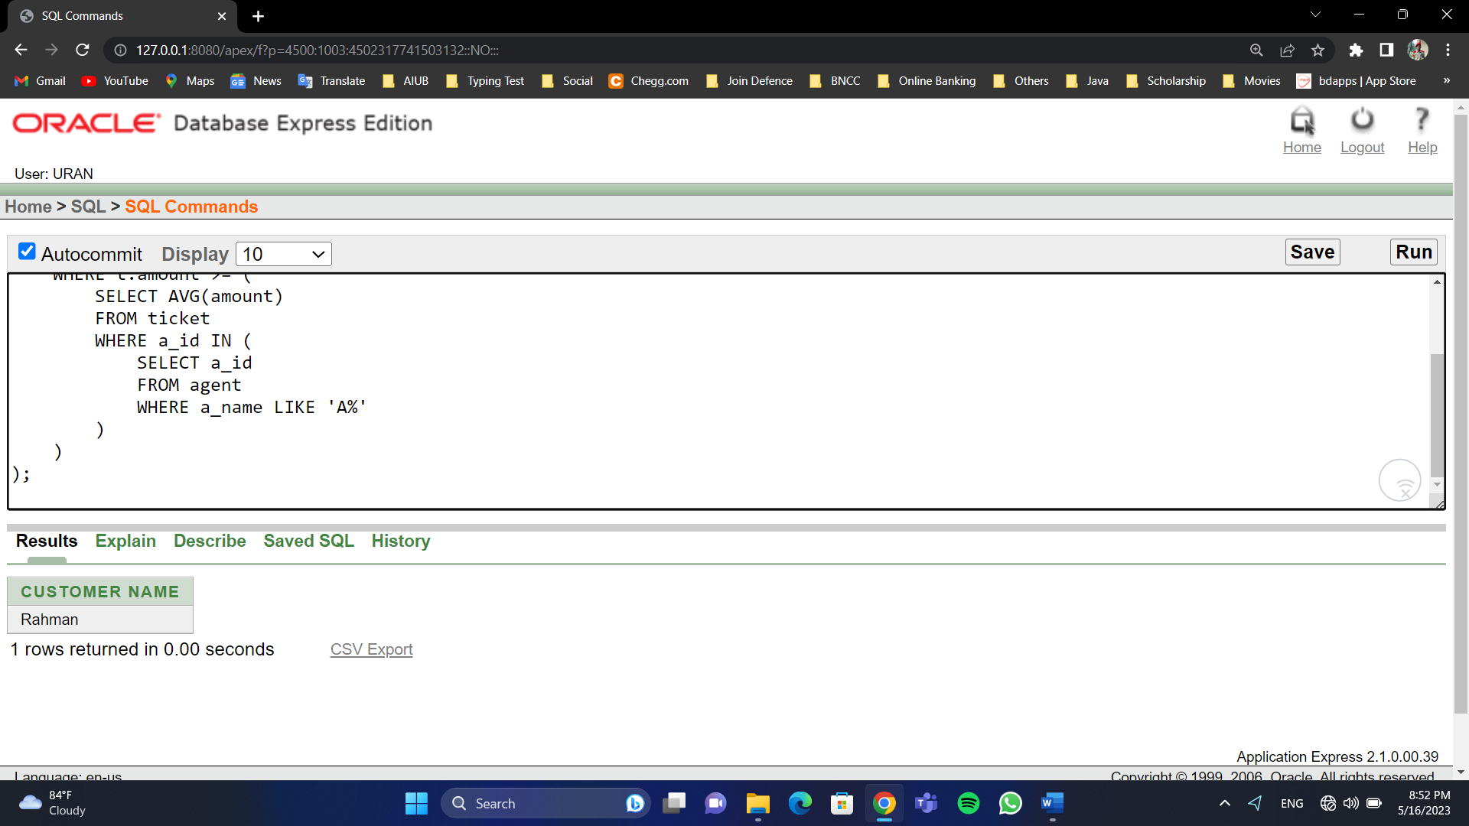

**View**

1. **Complex View**

**Question:** Create a complex view that combines information from multiple tables to provide a comprehensive overview of customers and their corresponding ticket details.

**Query:**

CREATE VIEW customer_ticket_view AS

SELECT c.c_id, c.c_name, t.t_id, t.amount, t.fare, t.departure, t.destination

FROM customer c, ticket t

WHERE c.c_id = t.c_id;

**Screenshot:**

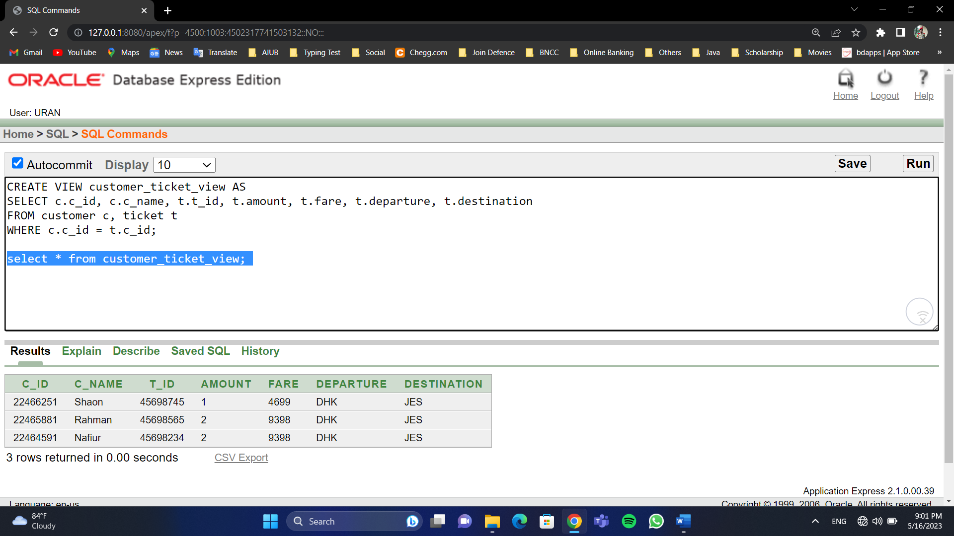

1. **Simple View**

**Question:** Create a simple view that displays the names and salaries of managers.

**Query:**

CREATE VIEW manager_salary_view AS

SELECT mgr_name, mgr_sal

FROM manager;

**Screenshot:**

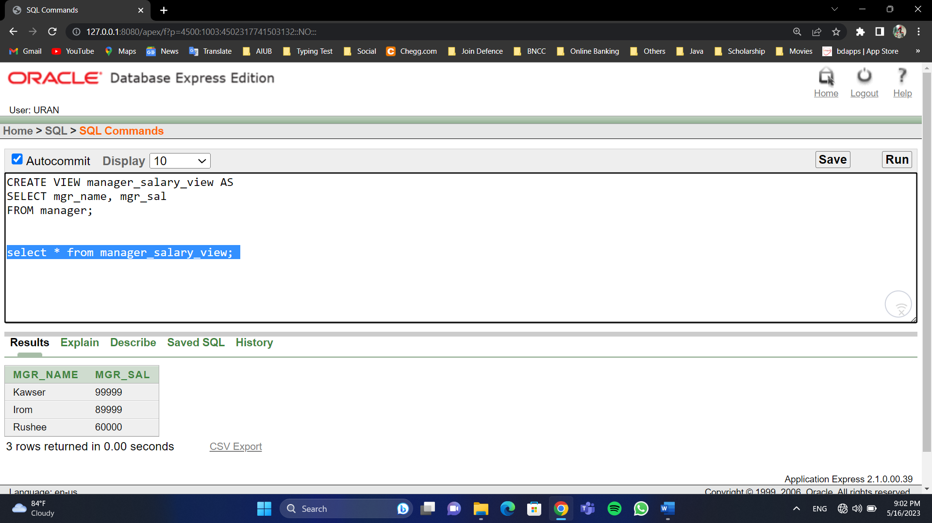

**Add Constraint**

**Question:** Add constraint in customer table payment history and it must be positive or 0 and not null.

**Query:**

ALTER TABLE customer

ADD CONSTRAINT check_pay_history_positive

CHECK (pay_history >= 0 AND pay_history IS NOT NULL);

**Screenshot:**

